**Software Testing**

**----------------------------**

Testing is the process of evaluating a system or its component(s) with the intent to find whether it satisfies the specified requirements or not.

Testing is executing a system in order to identify any gaps, errors, or missing requirements in contrary to the actual requirements.

This tutorial will give you a basic understanding on software testing, its types, methods, levels, and other related terminologies.

**Why to Learn Software Testing?**

In the IT industry, large companies have a team with responsibilities to evaluate the developed software in context of the given requirements. Moreover, developers also conduct testing which is called Unit Testing. In most cases, the following professionals are involved in testing a system within their respective capacities −

Software Tester

Software Developer

Project Lead/Manager

End User

Different companies have different designations for people who test the software on the basis of their experience and knowledge such as Software Tester, Software Quality Assurance Engineer, QA Analyst, etc.

## Applications of Software Testing

**Cost Effective Development** - Early testing saves both time and cost in many aspects, however reducing the cost without testing may result in improper design of a software application rendering the product useless.

**Product Improvement -** During the SDLC phases, testing is never a time-consuming process. However diagnosing and fixing the errors identified during proper testing is a time-consuming but productive activity.

**Test Automation -** Test Automation reduces the testing time, but it is not possible to start test automation at any time during software development. Test automaton should be started when the software has been manually tested and is stable to some extent. Moreover, test automation can never be used if requirements keep changing.

Quality Check - Software testing helps in determining following set of properties of any software such as

Functionality

Reliability

Usability

Efficiency

Maintainability

Portability

****MANUAL TESTING**** is a type of Software Testing where Testers manually execute test cases without using any automation tools. Manual Testing is the most primitive of all testing types and helps find bugs in the software system.

Any new application must be manually tested before its testing can be automated. Manual Testing requires more effort but is necessary to check automation feasibility.

Manual Testing does not require knowledge of any testing tool.

One of the Software Testing Fundamental is "****100% Automation is not possible****".

This makes Manual Testing imperative.

## **Goal of Manual Testing**

The key concept of manual testing is to ensure that the application is error free and it is working in conformance to the specified functional requirements.

Test Suites or cases, are designed during the testing phase and should have 100% test coverage.

It also makes sure that reported defects are fixed by developers and re-testing has been performed by testers on the fixed defects.

Basically, this testing checks the quality of the system and delivers bug-free product to the customer.

## **Types of Manual Testing:**

Below given diagram depicts Manual Testing Types.****In fact, any type of software testing type can be executed both manually as well using an automation tool.****

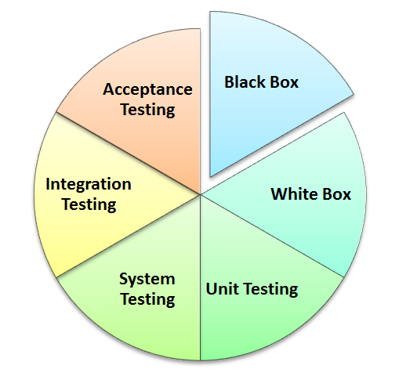

* Black Box Testing
* White Box Testing
* Unit Testing
* System Testing
* Integration Testing
* Acceptance Testing

## **How to perform Manual Testing**

1. Read and understand the software project documentation/guides. Also, study the Application Under Test (AUT) if available.
2. Draft Test cases that cover all the requirements mentioned in the documentation.
3. Review and baseline the test cases with Team Lead, Client (as applicable)
4. Execute the test cases on the AUT
5. Report bugs.
6. Once bugs are fixed, again execute the failing test cases to verify they pass.

## **Manual Testing vs Automation Testing**

|  |  |
| --- | --- |
| **Manual Testing** | **Automated Testing** |
| Manual testing requires human intervention for test execution. | [Automation Testing](https://www.guru99.com/automation-testing.html) is use of tools to execute test cases |
| Manual testing will require skilled labour, long time & will imply high costs. | Automation Testing saves time, cost and manpower. Once recorded, it's easier to run an automated test suite |
| Any type of application can be tested manually, certain testing types like ad-hoc and monkey testing are more suited for manual execution. | Automated testing is recommended only for stable systems and is mostly used for [Regression Testing](https://www.guru99.com/regression-testing.html) |
| Manual testing can become repetitive and boring. | The boring part of executing same test cases time and again is handled by automation software in Automation Testing. |

## **Tools to Automate Manual Testing**

* [Selenium](https://www.guru99.com/selenium-tutorial.html)
* [QTP](https://www.guru99.com/quick-test-professional-qtp-tutorial.html)
* [Jmeter](https://www.guru99.com/jmeter-tutorials.html)
* [Loadrunner](https://www.guru99.com/loadrunner-v12-tutorials.html)
* [TestLink](https://www.guru99.com/testlink-tutorial-complete-guide.html)
* [Quality Center(ALM)](https://www.guru99.com/hp-alm-free-tutorial.html)

## **Conclusion**

Manual testing is an activity where the tester needs to be very patient, creative &  open minded.

They need to think and act with an End User perspective.